Responses and treatment
Student: ………………………..…………..…..…..…………… Class: …..…….....………. Due date: …..…….…………………...
1. Based on the information in subtopic 18.4, write a descriptive caption for each of the following treatments or responses.
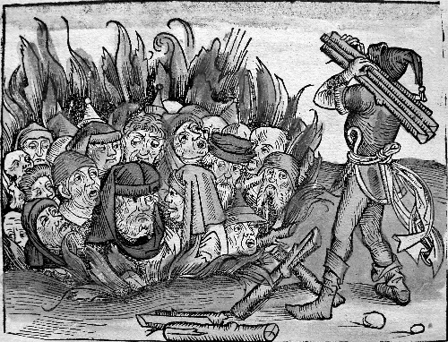 |  | 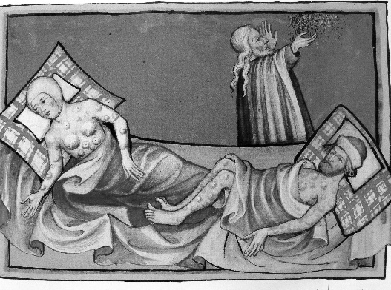
1. |  | 2.
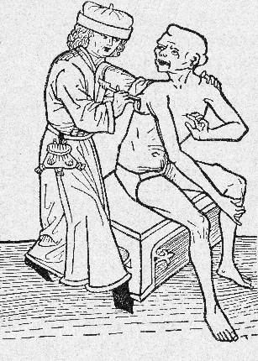  © Getty Images/NYPL/Science Source |  | 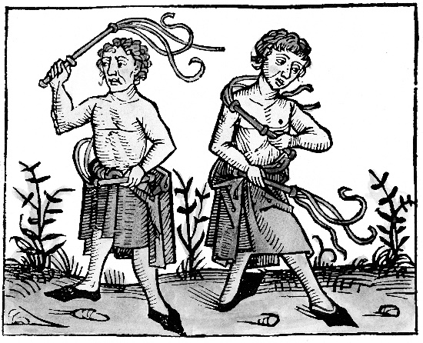  © Corbis Australia/Heritage Images
3. |  | 4.

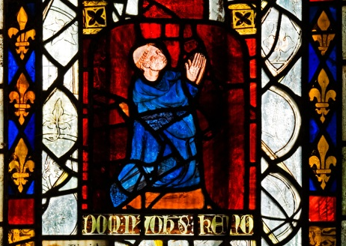  © Vivian Charlse/Alamy Stock Photo |  | © Getty Images/ Time & Life Pictures  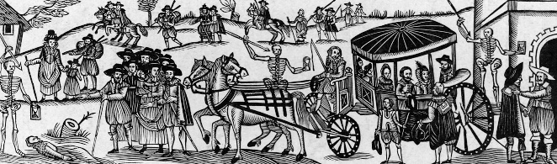
5. |  | 6.
2. Write down the appropriate number(s) to match the pictures with the following statements.

a. People looked for someone to blame for the disease.

b. People had no medical knowledge of the disease.

c. The Church and its teachings were looked to for help.

d. Fear and ignorance drove people to drastic measures.
3. Which of the above treatments and responses helped stop the spread of the disease? Why did this work?

4. Why do you think so many graphic images of the Black Death were made?

